**ECOVISIT: Monitor, Predict & Compare AQI**

**Mini Project 2 A Report**

Submitted in partial fulfillment of the requirement of University of Mumbai

For the Degree of

**(Computer Engineering)**

**By**

**1) Hunny MK Ahirwar ID No: TU3F2223025**

**2) Khushi Chaudhary ID No: TU3F2223042**

**Under the Guidance of**

**Dr. Sidharth Kalpagam**



**Department of Computer Engineering**

**TERNA ENGINEERING COLLEGE**

**Plot no.12, Sector-22, Opp. Nerul Railway station,**

**Phase-11, Nerul (w), Navi Mumbai 400706**

**UNIVERSITY OF MUMBAI**



**TERNA ENGINEERING COLLEGE, NERUL,**

**NAVI MUMBAI**

**Department of Computer Engineering**

Academic Year 2024-25

**CERTIFICATE**

This is to certify that the mini project 1 A entitles “**ECOVISIT: Monitor, predict & compare AQI**” is a bona fide work of

**1) Hunny MK Ahirwar ID No: TU3F2223025**

**2) Khushi Chaudhary ID No: TU3F2223042**

submitted to the University of Mumbai in partial fulfillment of the requirement for the award of the Bachelor of Engineering (Computer Engineering).

**Guide Head of Department Principal**

**Project Report Approval**

This Mini Project 1A Report – entitled “**ECOVISIT: Monitor, predict & compare AQI**” by following students is approved for the degree of ***T.E. in "Computer Engineering"***.

**Submitted by:**

**1) Hunny MK Ahirwar ID No: TU3F2223025**

**2) Khushi Chaudhary ID No: TU3F2223042**

Examiners Name & Signature:

1.---------------------------------------------------------

2.----------------------------------------------------------

Date: ---------------------------------

Place: ---------------------------------

**Declaration**

We declare that this written submission represents our ideas in our own words and where others' ideas or words have been included, we have adequately cited and referenced the original sources. We also declare that we have adhered to all principles of academic honesty and integrity and have not misrepresented or fabricated or falsified any idea/data/fact/source in our submission. We understand that any violation of the above will be cause for disciplinary action by the Institute and can also evoke penal action from the sources which have thus not been properly cited or from whom proper permission has not been taken when needed.

|  |  |  |
| --- | --- | --- |
| **Hunny MK Ahirwar** | **ID No: TU3F2223025** | --------------------------- |
| **Khushi Chaudhary** | **ID No: TU3F2223042** | --------------------------- |

Date: _____________________

Place: _____________________

**Acknowledgement**

We would like to express our sincere gratitude towards our guide **Dr Siddharth Kalpagam**, Mini Project Coordinators **Dr Siddharth Kalpagam** for their help, guidance and encouragement, they provided during the project development. This work would have not been possible without their valuable time, patience and motivation. We thank them for making our stint thoroughly pleasant and enriching. It was great learning and an honor being their student.

We are deeply thankful to **Dr. Kishore Sakure (H.O.D Computer Department)** and entire team in the Computer Department. They supported us with scientific guidance, advice and encouragement, they were always helpful and enthusiastic and this inspired us in our work.

We take the privilege to express our sincere thanks to **Dr. L. K. Ragha**our Principal for providing the encouragement and much support throughout our work.

|  |  |  |
| --- | --- | --- |
| **Hunny Ahirwar** | **ID No: TU3F2223025** | --------------------------- |
| **Khushi Chaudhary** | **ID No: TU3F2223042** | --------------------------- |

Date: _____________________

Place: __________________

## Abstract

EcoVisit is an innovative web platform designed to enhance environmentally-conscious travel planning. By integrating AI-driven AQI predictions, real-time air quality data, and historical comparisons, it empowers users to make informed travel decisions. The platform also promotes sustainable travel practices and supports local conservation efforts, making it a smart and eco-friendly tool for travelers. EcoVisit’s user-friendly interface, interactive map, and actionable insights ensure a seamless and impactful travel planning experience. The platform features an interactive map of India displaying the air quality index (AQI) for major tourist destinations, AI-driven AQI predictions, historical data comparisons, and real-time news highlights related to air quality changes.

By promoting eco-friendly travel practices and supporting local conservation efforts, EcoVisit aims to create a smart, witty, and environmentally conscious travel experience. Utilizing advanced AI prediction algorithms, the website not only displays current AQI values but also forecasts future air quality trends, enabling users to make informed decisions about outdoor activities and health precautions. The platform features an intuitive user interface, allowing visitors to search for specific cities and view detailed AQI

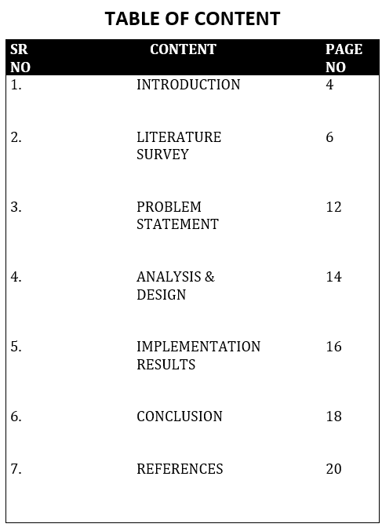

|  |  |  |
| --- | --- | --- |
|  |  |  |
|  |  |  |
|  |  |  |
|  |  |  |

**Chapter 1**

**Introduction**

**1.1 Need of the project**

As urbanization and industrialization continue to rise in India, air pollution has become a significant public health concern. Poor air quality is linked to a range of health issues, including respiratory diseases, cardiovascular problems, and premature deaths. Recognizing the urgent need for accessible information on air quality

**1.2 Scope of the project**

* **Real-Time Air Quality Data**: EcoVisit provides up-to-date AQI readings for various cities, empowering users to monitor air quality conditions in their vicinity.
* **AI-Powered Predictions**: By leveraging AI algorithms, EcoVisit offers predictive analytics on air quality trends. Users can anticipate changes in air quality and plan their activities accordingly, promoting healthier lifestyle choices.
* **User-Friendly Interface**: EcoVisit is designed to be intuitive and accessible, making it easy for users of all ages and backgrounds to navigate. The website will feature interactive maps, city-specific data, and informative resources, ensuring that users can quickly find the information they need.
* **Awareness and Education**: The website will serve as an educational platform, raising awareness about the sources and effects of air pollution

**1.3 Aim of the project**

**Motive:** The primary aim of the EcoVisit project is to develop a user-friendly and informative website that provides real-time air quality information and AI-driven predictions for various Indian cities. This platform seeks to enhance public awareness about air quality issues, promote healthier lifestyle choices, and contribute to a cleaner environment. The motive behind EcoVisit is centered on public health awareness, empowering individuals and communities with knowledge about air quality so they can take informed actions to protect their health. By encouraging users to adjust their outdoor activities based on air quality conditions, EcoVisit aims to reduce health risks associated with air pollution while raising awareness about pollution sources and promoting environmental sustainability.

**Ethical considerations:** These are paramount to EcoVisit’s mission. The project prioritizes data privacy by ensuring secure collection and storage of user data, adhering to data protection regulations, and allowing users control over their information. Accuracy of information is crucial; thus, the project commits to providing reliable AQI data and predictions, ensuring users can trust the information for their health and safety. Transparency is emphasized by clearly communicating data sources and methodologies used in AI predictions. Inclusivity is also a focus, with the website designed to be accessible to all users, including those with disabilities, and responsible messaging that avoids sensationalism, focusing instead on constructive actions users can take to improve air quality.

**Measuring success**: It involves various metrics, including user engagement metrics such as the number of visitors, page views, and average session duration to assess interest in the content. Feedback mechanisms and surveys will gather insights on user satisfaction and the impact of the website on behavior regarding air quality. The accuracy of AI-driven predictions will be monitored by comparing them with actual AQI data over time. Additionally, community involvement will be evaluated through reported air quality issues and user engagement on the platform. The educational impact will be assessed by tracking interactions with educational resources, while policy impact will be measured by tracking mentions of the website in research papers, news articles, or policy discussions. Through these aims, motives, ethical considerations, and success metrics, the EcoVisit project aspires to create a meaningful impact on public awareness, health, and environmental sustainability in India.

**Chapter 2**

**Problem Statement**

**Background:** Air quality has emerged as a critical public health issue, particularly in urban areas of India, where rapid industrialization, vehicular emissions, and construction activities contribute to elevated levels of air pollution. According to the World Health Organization (WHO), air pollution is responsible for millions of premature deaths annually, with many of these occurring in densely populated regions. In India, cities often experience hazardous air quality levels, especially during certain seasons, significantly impacting the health and well-being of residents. Despite the growing concern, access to real-time air quality information remains limited, making it challenging for individuals to make informed decisions about their health and activities.

**Problem Description:** The lack of accessible, real-time air quality data poses a significant challenge for citizens, tourists, and policymakers. Many individuals are unaware of the current air quality levels in their areas or how to interpret AQI readings, which can lead to adverse health effects. Tourists may also find it difficult to plan their trips effectively, as they lack reliable information about air quality conditions in various cities. Furthermore, policymakers and researchers require comprehensive data to formulate effective strategies for improving air quality and public health. The absence of an integrated platform that provides real-time data, predictions, and educational resources exacerbates these issues, limiting public awareness and engagement in air quality management.

**Solution:** The EcoVisit project aims to address these challenges by developing a comprehensive AQI website that offers real-time air quality data, AI-driven predictions, and educational resources for various Indian cities. The platform will integrate data from reliable sources to provide current AQI levels, pollutant concentrations, and health advisories. By employing advanced machine learning algorithms, EcoVisit will forecast future air quality trends, enabling users to plan their activities accordingly. The website will feature an intuitive user interface, making it easy for users to search for specific cities and access relevant information. Additionally, EcoVisit will serve as an educational resource, raising awareness about the sources and effects of air pollution while providing guidelines for reducing personal exposure. By fostering community engagement and facilitating informed decision-making, EcoVisit aims to empower individuals and contribute to the broader goal of improving air quality and public health in India.

**Chapter 3**

**Literature Review**

|  |  |  |  |
| --- | --- | --- | --- |
| **Research Paper** | **Authors & Year** | **Summary** | **What we understood** |
| **Impact of Air Quality on Tourism: An Analysis of Tourist Behavior and Travel Choices** | **Sharma N & Joshi A. (2023)** | **Analyzes how variations in air quality impact tourist behavior and travel choices, with a focus on urban and popular tourist areas.** | **Highlighted the relationship between air quality and tourism but did not provide actionable solutions for travelers.** |
| **Advanced Machine Learning Models for Predicting Air Quality: A Comprehensive Review** | **Lee J & Kim S (2022)** | **Reviews recent advancements in machine learning models for air quality prediction, focusing on their effectiveness and applications.** | **Provided insights into advanced ML techniques but lacked practical application in travel planning** |
| **The impact of “Air Pollution” on Tourism** | **Chen Y & Huan S. (2021)** | **Analyses how air pollution affects tourism** | **The co-relation between Air quality & tourism** |

**Limitations of Present Models**

* **Limited Scope**: Most models focus on urban areas, neglecting tourist destinations.
* **Lack of Predictive Analysis**: Few platforms offer forward-looking AQI predictions.
* **User Engagement**: Current platforms are often static with little emphasis on user interaction or sustainable practices.

**Our Advantage:**

* **Broader Coverage**: EcoVisit extends monitoring to tourist spots, offering detailed AQI insights.
* **Predictive Capabilities**: Our AI-driven model predicts future AQI, aiding in proactive travel planning.
* **Interactive Platform**: Engages users through a dynamic map, real-time alerts, and eco-friendly travel tips, promoting environmental awareness.

**Chapter 4**

**4.1 Design and Implementation**

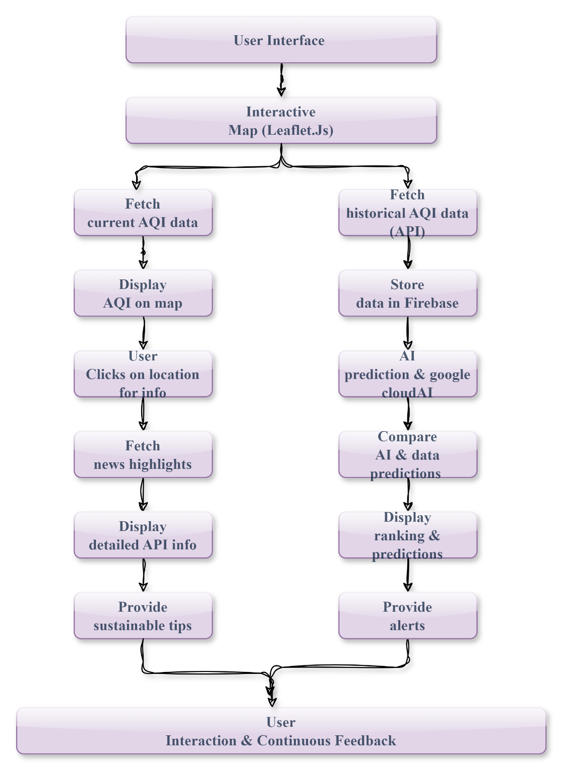

**4.1. FLOWCHART**

**4.2 Methodology**

1. **Data Collection:** Utilize APIs like AirVisual or OpenWeatherMap to gather real-time and historical AQI data for major tourist destinations across India.
2. **AI Integration**: Implement machine learning models using Google Cloud AI or Azure to predict future AQI trends based on historical data.
3. **Frontend Development:** Create an interactive, responsive user interface using React.js and Leaflet.js to display AQI data on a map of India.
4. **Backend Development**: Use Firebase and Node.js for data management, user authentication, and API integration.
5. **Feature Implementation:**
6. **Interactive Map:** Display real-time AQI data, color-coded based on air quality levels.
7. **AQI Prediction:** Provide monthly forecasts and historical comparisons for travel planning.
8. **Sustainability Features:** Offer eco-friendly travel tips and highlight local conservation efforts.
9. **Testing & Deployment:** Ensure platform stability, accuracy of predictions, and user experience through continuous testing and iterative improvements.

**4.3 Key Features**:

* **Interactive AQI Map of India**

- Display an interactive map showing AQI for major tourist destinations.

- Color-code states based on AQI levels (e.g., green for good, yellow for moderate, red for unhealthy).

- Show AQI values in numbers for each location.

* **AI-Driven AQI Prediction Model**

- Utilize AI to predict future AQI levels for various tourist destinations based on historical data.

- Provide monthly forecasts to help users plan their travels in advance.

* **Historical Data Comparison**

- Compare AQI data from the past few months to identify trends and changes.

* **News Highlights**

- Display news highlights related to sudden changes in air quality for specific locations.

- Provide alerts for significant AQI changes, helping users stay informed about environmental conditions.

**Chapter 5**

**Results and Discussions**

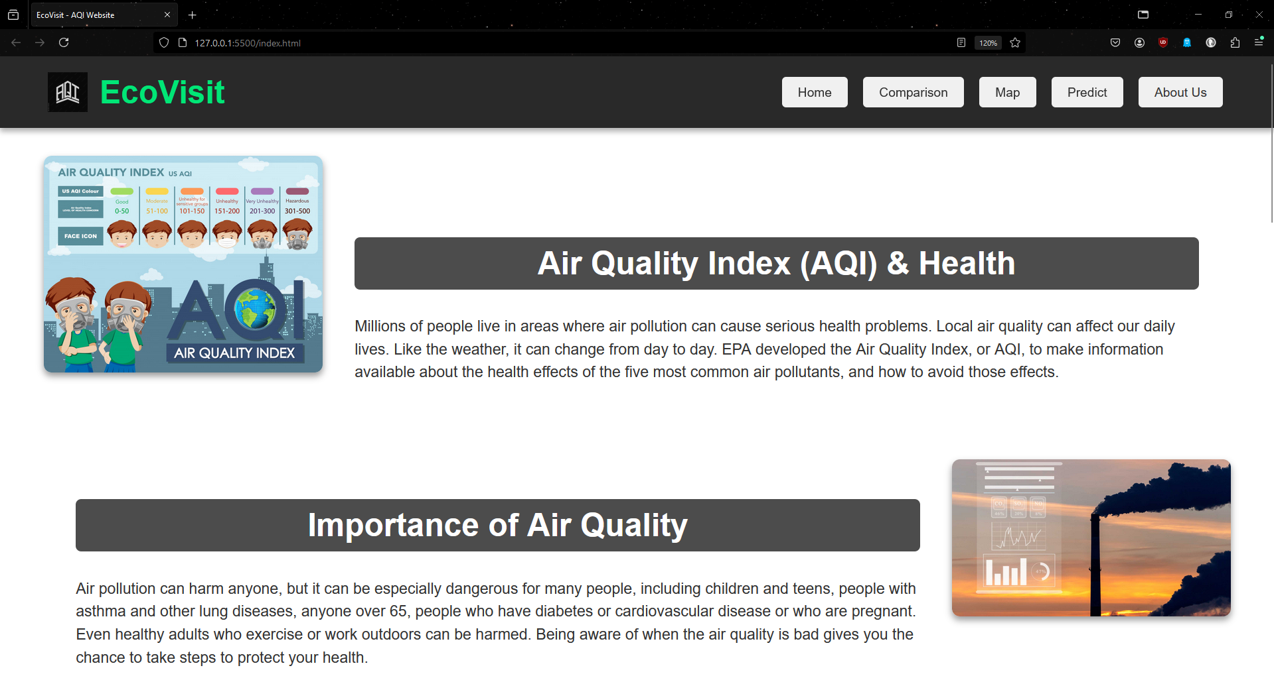

***Fig 5.1. Home Page of the website***

*The introductory page of a website, typically serving as a table of contents for the site.*

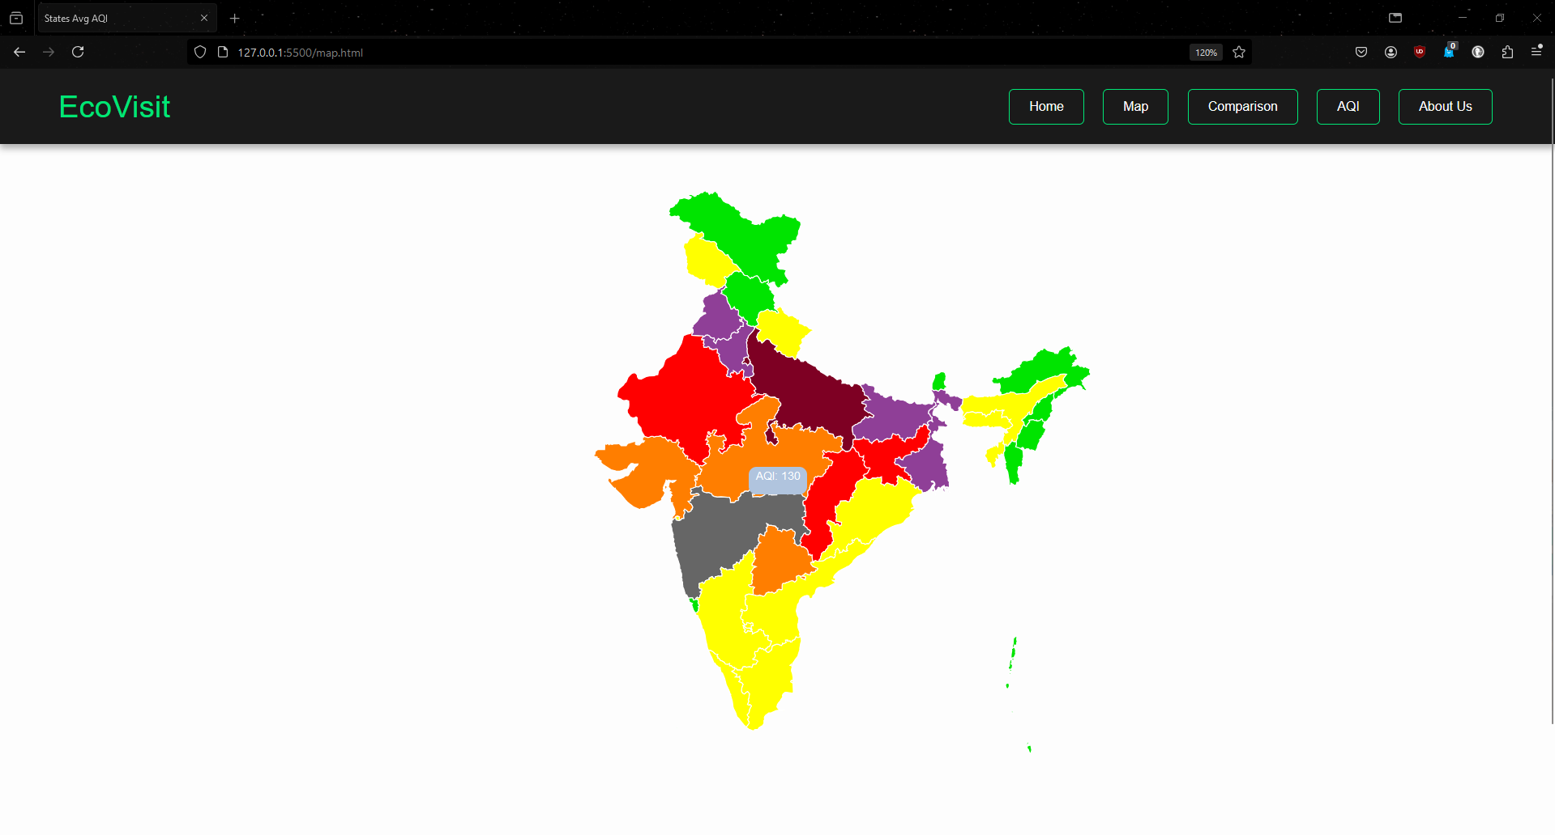

***Fig 5.2. Map showing the AQI of different Indian states***

*An interactive map with color coded according to AQI values*

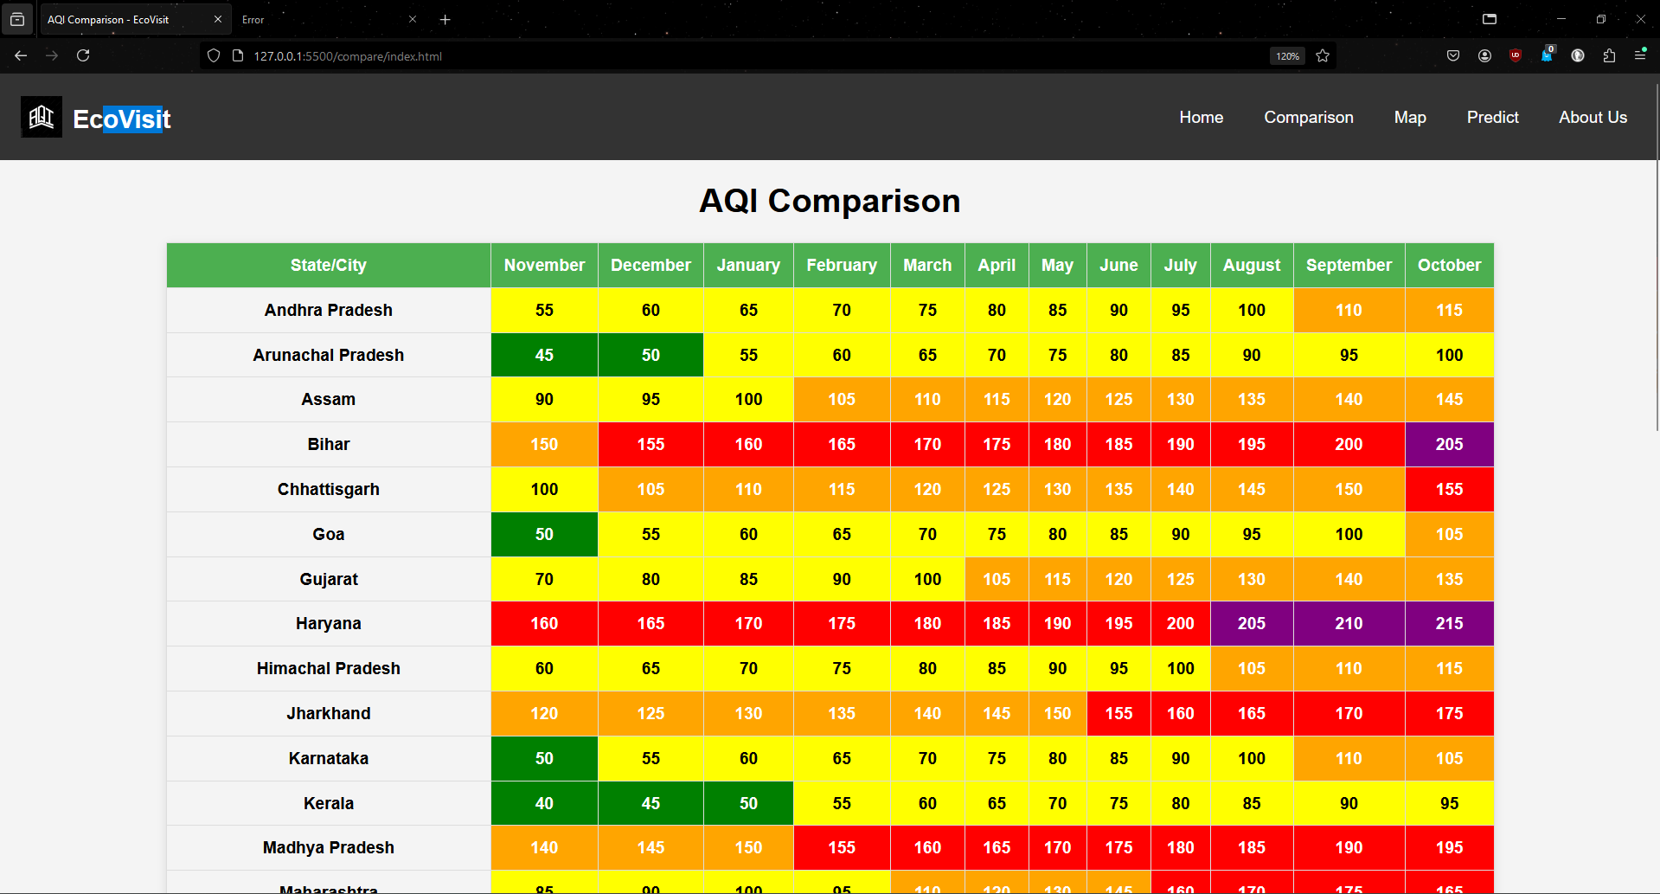

***Fig 5.3. Live AQI for different Indian states***

*AQI of different Indian states according to the months of the year*

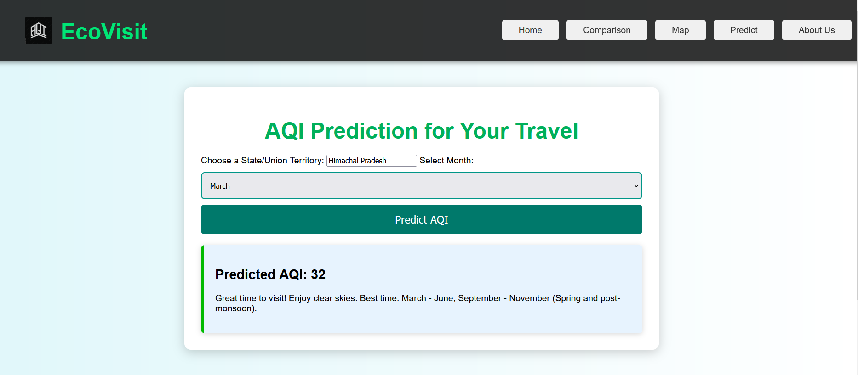

***Fig 5.4. Page for AQI prediction for different months***

*Prediction feature for efficient travel planning according to the weather forecast*

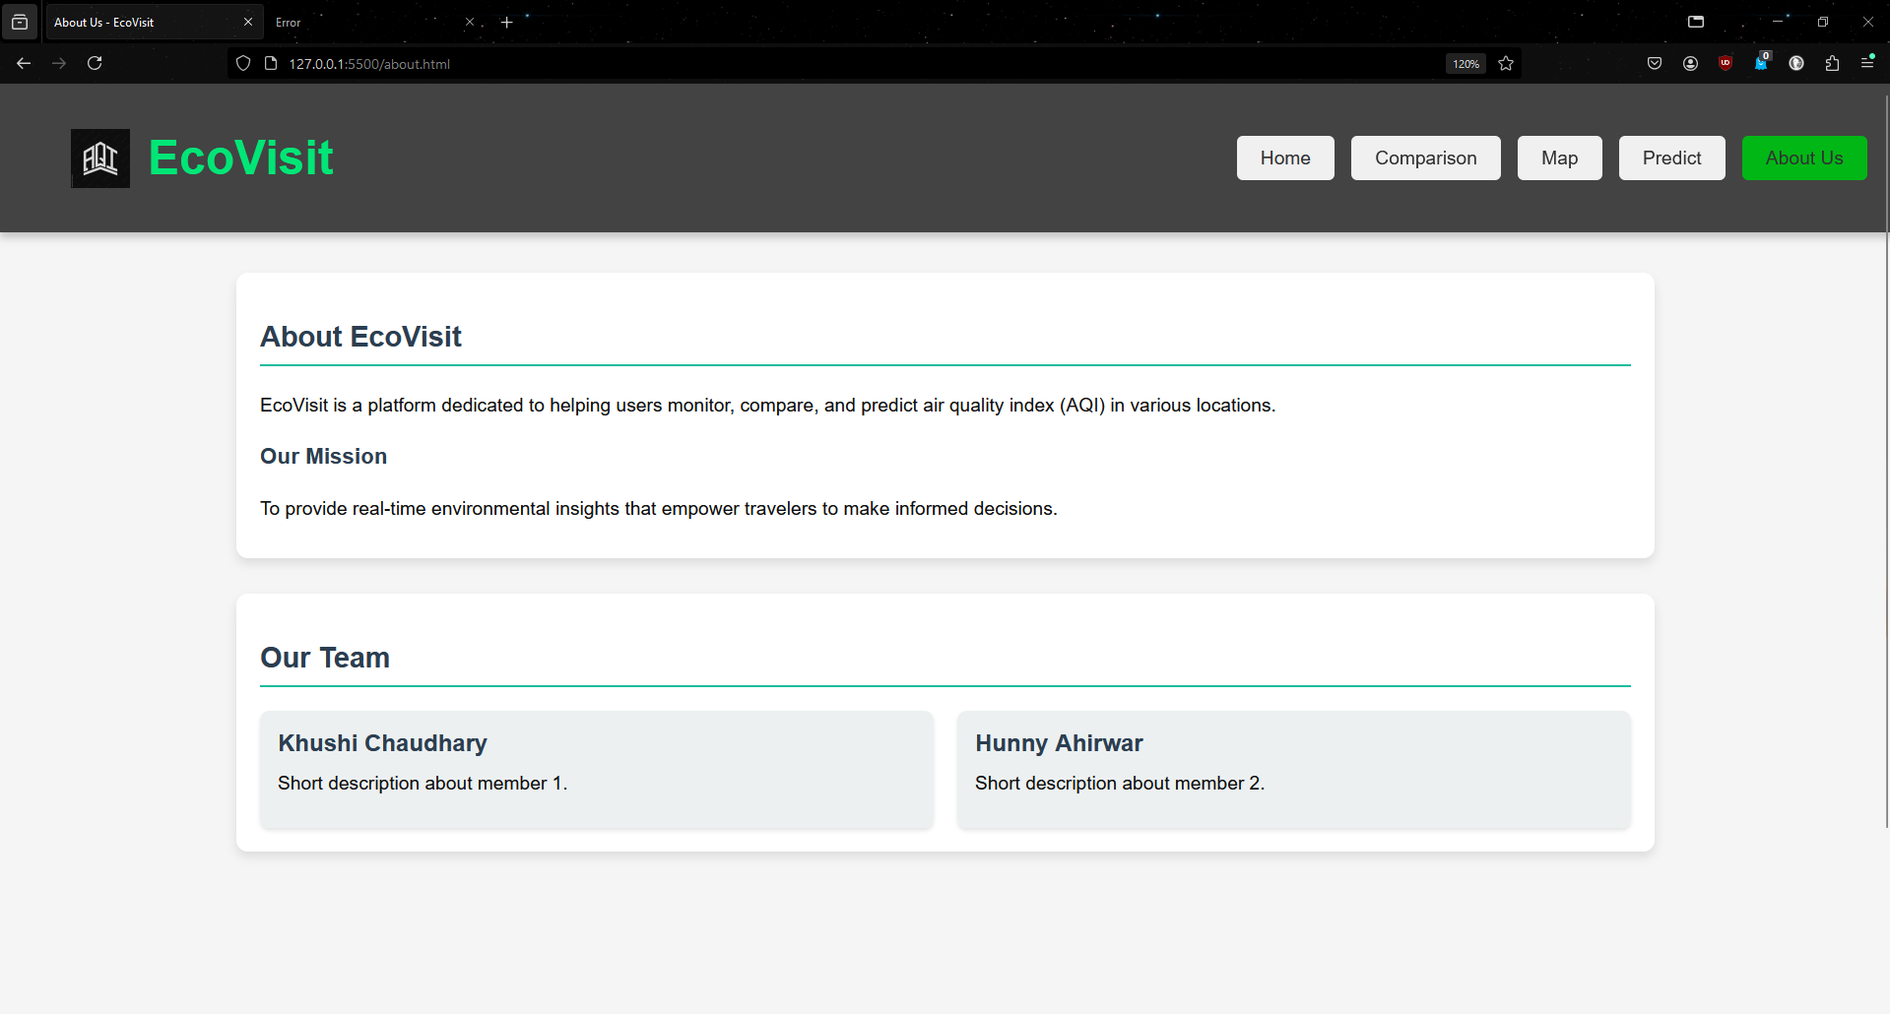

***Fig 5.5. About Us page***

*Provides details about the project and also the founders of the site*

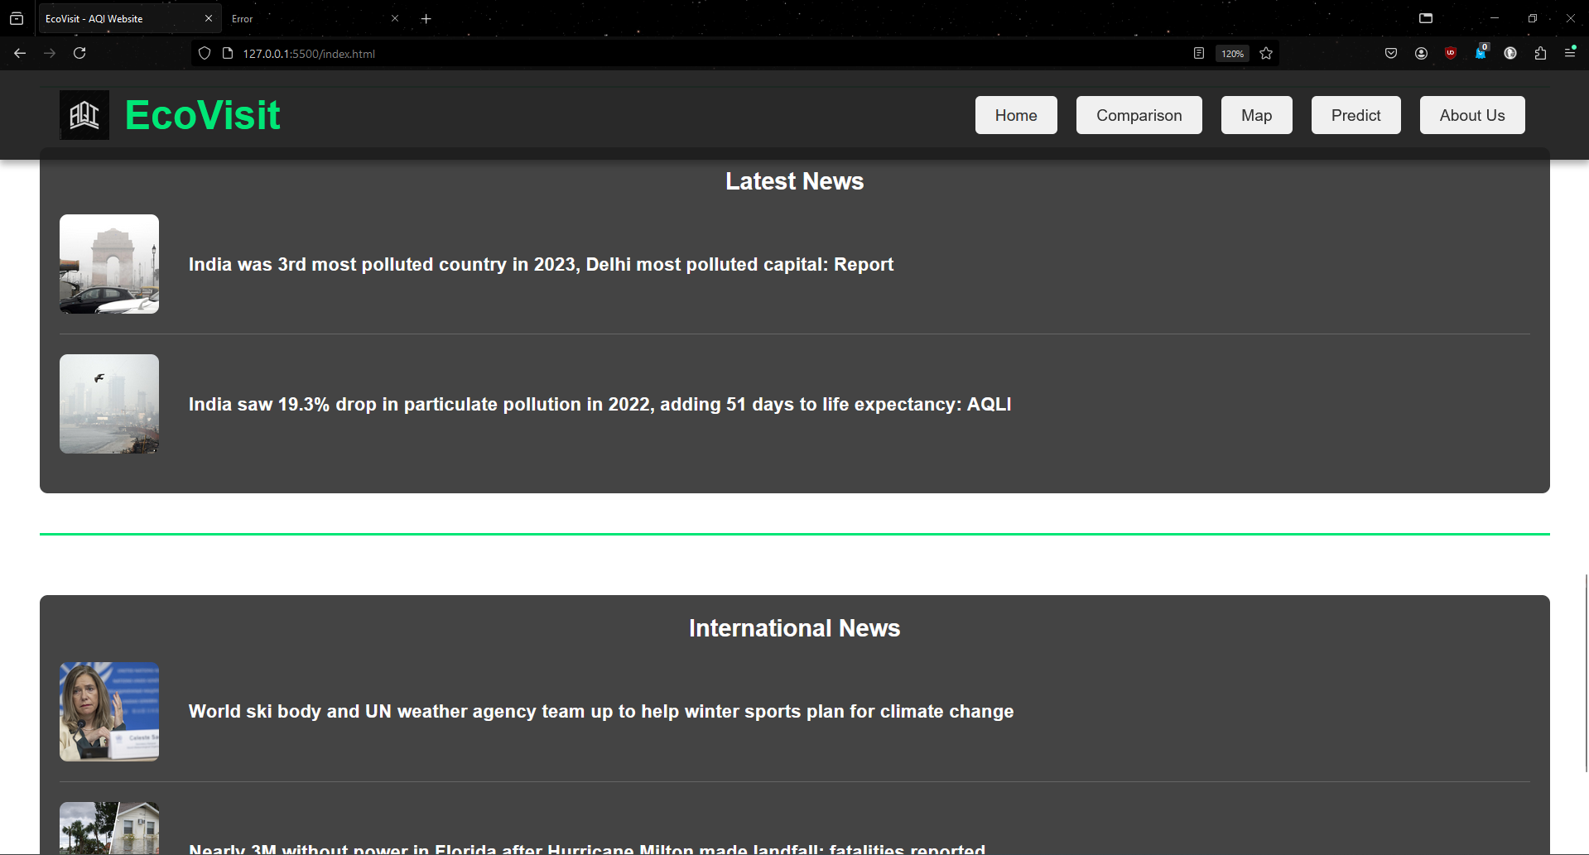

***Fig 5.6. News Section of the site***

*Displaying the national and international news related to the environment*

**Chapter 6**

**5.1. Conclusion and Future Scope**

In this project, we successfully developed an AQI (Air Quality Index) website named *EcoVisit* that provides real-time air quality information for various Indian cities. The website includes features like a city search, AQI predictions, tourism recommendations, and a news section to keep users informed about air quality issues. By integrating APIs such as OpenWeatherMap, we were able to display accurate AQI data and monthly averages for multiple cities. The website follows a dark-themed aesthetic to ensure a visually appealing and consistent user experience. We achieved a seamless navigation flow across pages like the AQI, comparison, and map sections, enhancing the overall user interface.

**Learnings:**

1. API Integration: We learned how to effectively fetch and display real-time data using APIs, which was instrumental in providing updated AQI information to users.
2. Frontend Development: We gained experience in building responsive and dynamic web pages using HTML, CSS, and JavaScript, enhancing our skills in creating visually appealing interfaces.
3. Web Design Principles: Working on the dark theme and ensuring a consistent design across various sections of the website helped us understand the importance of cohesive design in improving user experience.
4. Navigation and User Interaction: Implementing features like hover effects on the map and clickable headlines in the news section refined our understanding of interactive web design.

**5.2. Future Scope**

1. Expand AQI Coverage: We plan to expand the AQI data coverage to include more cities and even international locations, making *EcoVisit* a global air quality platform.
2. Additional Features: Implementing user login and registration for personalized recommendations, favorite city tracking, and AQI alert notifications could enhance user engagement.
3. Machine Learning Integration: Introducing predictive analysis using machine learning models for future AQI trends can provide users with insights into potential changes in air quality.
4. Mobile Optimization: Developing a mobile-friendly version of the website or creating a dedicated mobile app could improve accessibility and user experience on various devices.

This project has been a valuable experience in building a functional, real-time data-driven application, and we look forward to further enhancing its capabilities and features in the future.

**References**

*•* ***"Air Quality"*** *by Thad Godish*

* *A comprehensive book on air quality, covering the basics of pollutants, their effects, and management strategies. It offers a scientific perspective that could be helpful for understanding AQI and its impact.*

*•* ***"Principles of Environmental Science: Inquiry and Applications"*** *by William P. Cunningham and Mary Ann Cunningham*

* *This book provides an overview of environmental science concepts, including air quality and pollution management, offering foundational knowledge for understanding AQI data.*

*•* ***"Fundamentals of Air Pollution"*** *by Daniel Vallero*

* *An in-depth look into air pollution fundamentals, including monitoring and management of air quality, making it useful for understanding the context behind AQI values.*

*•* ***HTML and CSS: Design and Build Websites"*** *by Jon Duckett*

* *A comprehensive guide to understanding and building modern websites using HTML and CSS. It’s ideal for both beginners and experienced developers looking to refine their skills.*

*•* ***"JavaScript and JQuery: Interactive Front-End Web Development"*** *by Jon Duckett*

* *This book covers the essentials of JavaScript and JQuery for creating interactive and dynamic web pages, making it valuable for implementing features like API integration and responsive design.*

*•* ***"Learning Web Design: A Beginner's Guide to HTML, CSS, JavaScript, and Web Graphics"*** *by Jennifer Robbins*

* *A beginner-friendly guide to mastering the basics of web design and development, covering HTML, CSS, JavaScript, and graphic design elements.*

*•* ***"Responsive Web Design with HTML5 and CSS"*** *by Ben Frain*

* *Focuses on creating responsive websites using the latest standards in HTML5 and CSS, which is crucial for developing mobile-friendly versions of web applications.*